Pre-Reading

The first theft
The first new word you find here is 因为 (yin1wei), which simply means “because.” The second part of this sentence begins with 所以 (suo3yi3) which means “therefore,” 所以 usually follows 因为. Unlike the 虽然，但是 construction found in the previous story, 因为，所以, therefore is optional, and usually more formal. Thus, because the city is small, it is very 容易 (rong2yi4) easy to 发现 (fa1xian4) realize/discover that something is missing. You may have already encountered the character 少 (shao3), which is most often used in a set phrase, such as 多少 (duo1shao3), which means "how much" and literally translates to (many) 多 (few ) 少. Thus, the author says that it’s easy to discover that there are fewer things because the city is small. Here is an additional example to illustrate the way 少了 works: 今天我们班少了两个学生 (Today our class is missing two students.)
Story Character Count = 64
Story Character Count = 64
In the second sentence, the character 从 (cong2) is a preposition meaning from. So, 有一天, there was a day, that the speaker's mom returned from the university and said that she realized that someone had stolen the 学校用品. Here 学校 (xue2xiao4) campus modifies 用品 (yong4pin3), which is made up of the character 用use and 品product, so 用品 refers to products that we use.
In the final sentence, the speaker identifies the things that were stolen: 白纸, 铅笔, 钢笔, 书, 书包, and 笔记本. The first words is 白纸 (bai2zhi3) paper, made up of the characters 白 white and 纸 paper. The next words is 铅笔 (qian1bi3) pencil. The character 笔 is used to refer to all writing utensils and is composed of the top part, which means bamboo and the bottom part which means hair. The character 铅 means lead, and like the character after it, has a simplified component of 金 (jin1) gold on the left side. The majority of any metallic metals from the earth will be made up of the character gold. Next in the sequence is 钢笔 (gang1bi3), and 钢 means steel, but steel pen or 钢笔 refers to a fountain pen, which is often used for writing Chinese characters. The fourth word is 书 (shu1) book. After 书 you will see 书包 (shu1bao1), which means book bag. 包 as a verb means to contain but as a noun it can be used to refer to basically any type of bag. And the final word is 笔记本 (bi3ji4ben3) notebook. The second character 记means to record and the last character 本 means book or notebook. In fact, 本 is also used as a classifier for books. For example, you may see a sentence like this: 他偷了三本书, which simply means "He stole three books."

Vocabulary/Writing
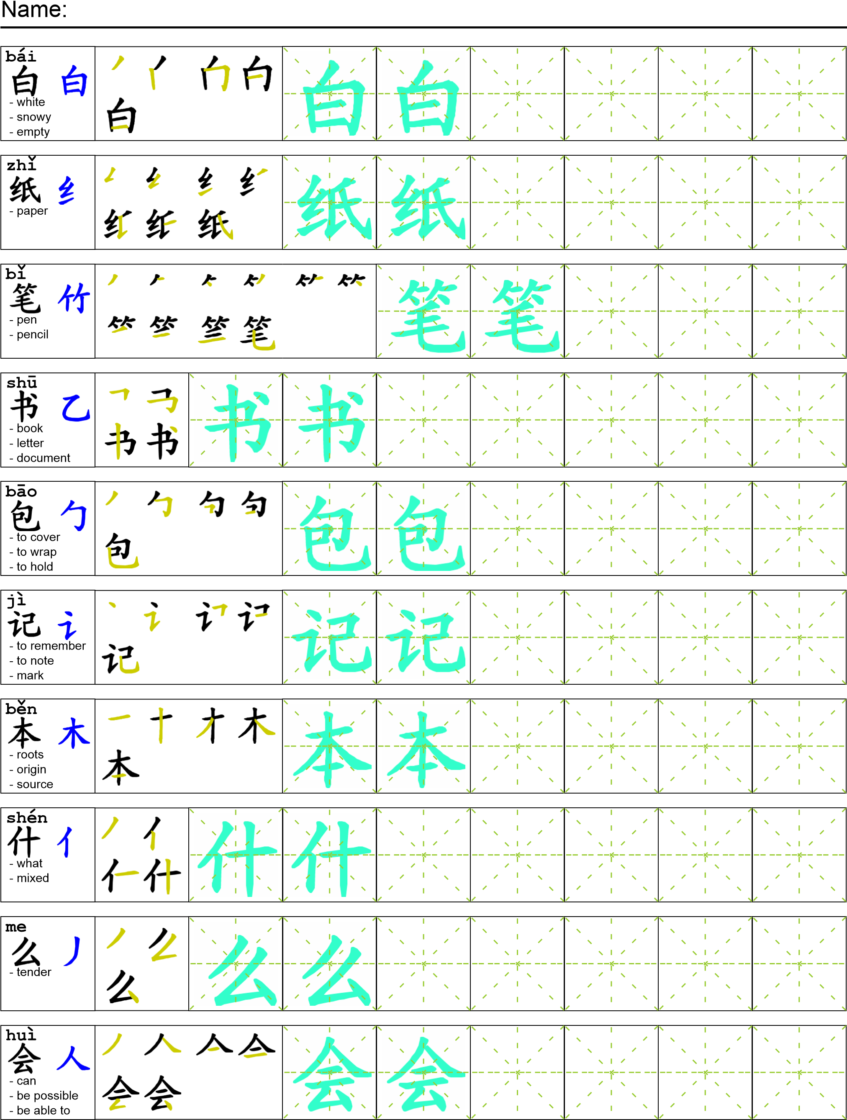

Reading

就是因为我们的城市很小，所以很容易会发现少了什么东西。有一天我妈妈从大学回来说“今天我们发现有人偷了学校用品。有人偷了白纸，铅笔，钢笔，书，书包，还偷了笔记本。
Task Completion
Once all tasks are complete turn the assignment in to collect the points for the project.
Task 1: Trace the vocabulary and copy the reading into your notebook.

Task 2: Answer Comprehension Questions

Task 3: Write the Pinyin for the Reading

Task 4: Translate the Reading into English

Task 5: Record yourself reading the passage.

Comprehension Questions
- Write the Chinese character for three things that were stolen. _______________________________
- Why was it easy to realize that something was stolen? _____________________________________
- What character was used to express missing something? ___________________________________

